**User Manual**

**Unicorn Charity Club Private Site**

**Introduction**

Current version of the web application is only a front-end with no functionalities added (except login authentication and some data fetched from database). This manual will briefly go over each completed module and the functionality they are supposed to have.

**Login**

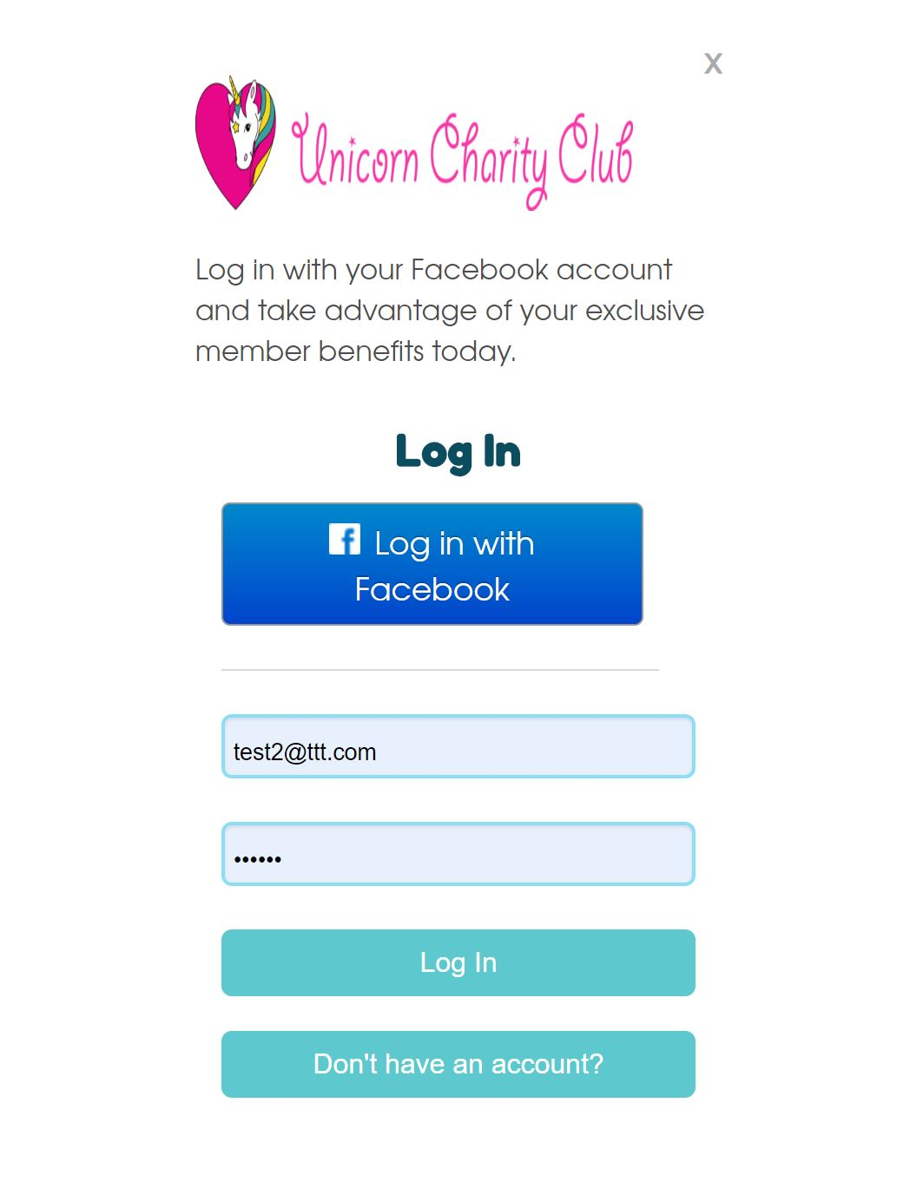

Users who are registered can log in using their email and password.

Users can log in with Facebook.

If user is not registered, they can make an account.

**Register**

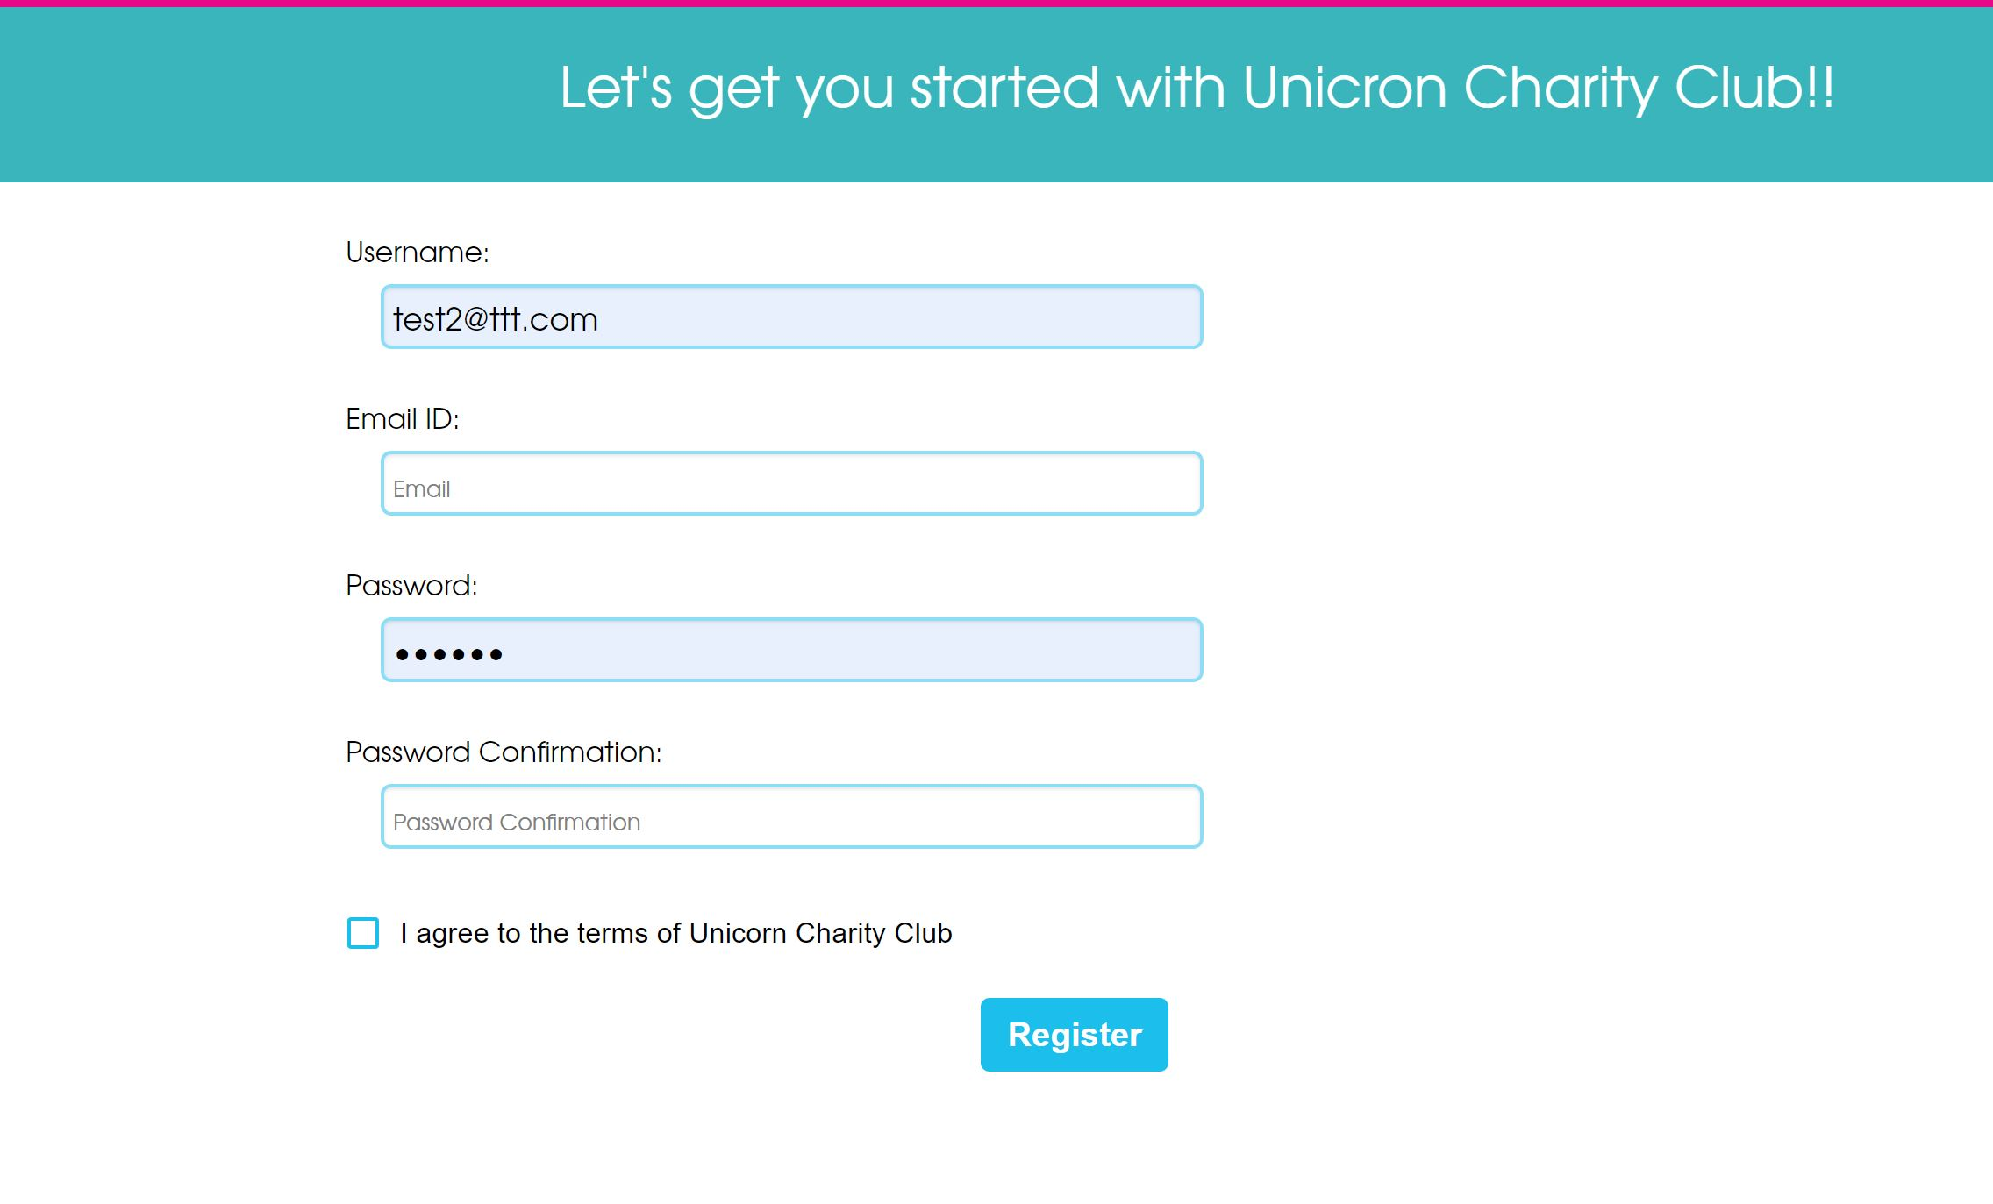

Users can register by providing a username which is not already in use, an email id, and a valid password. Users must agree to the terms before registering.

**Homepage**

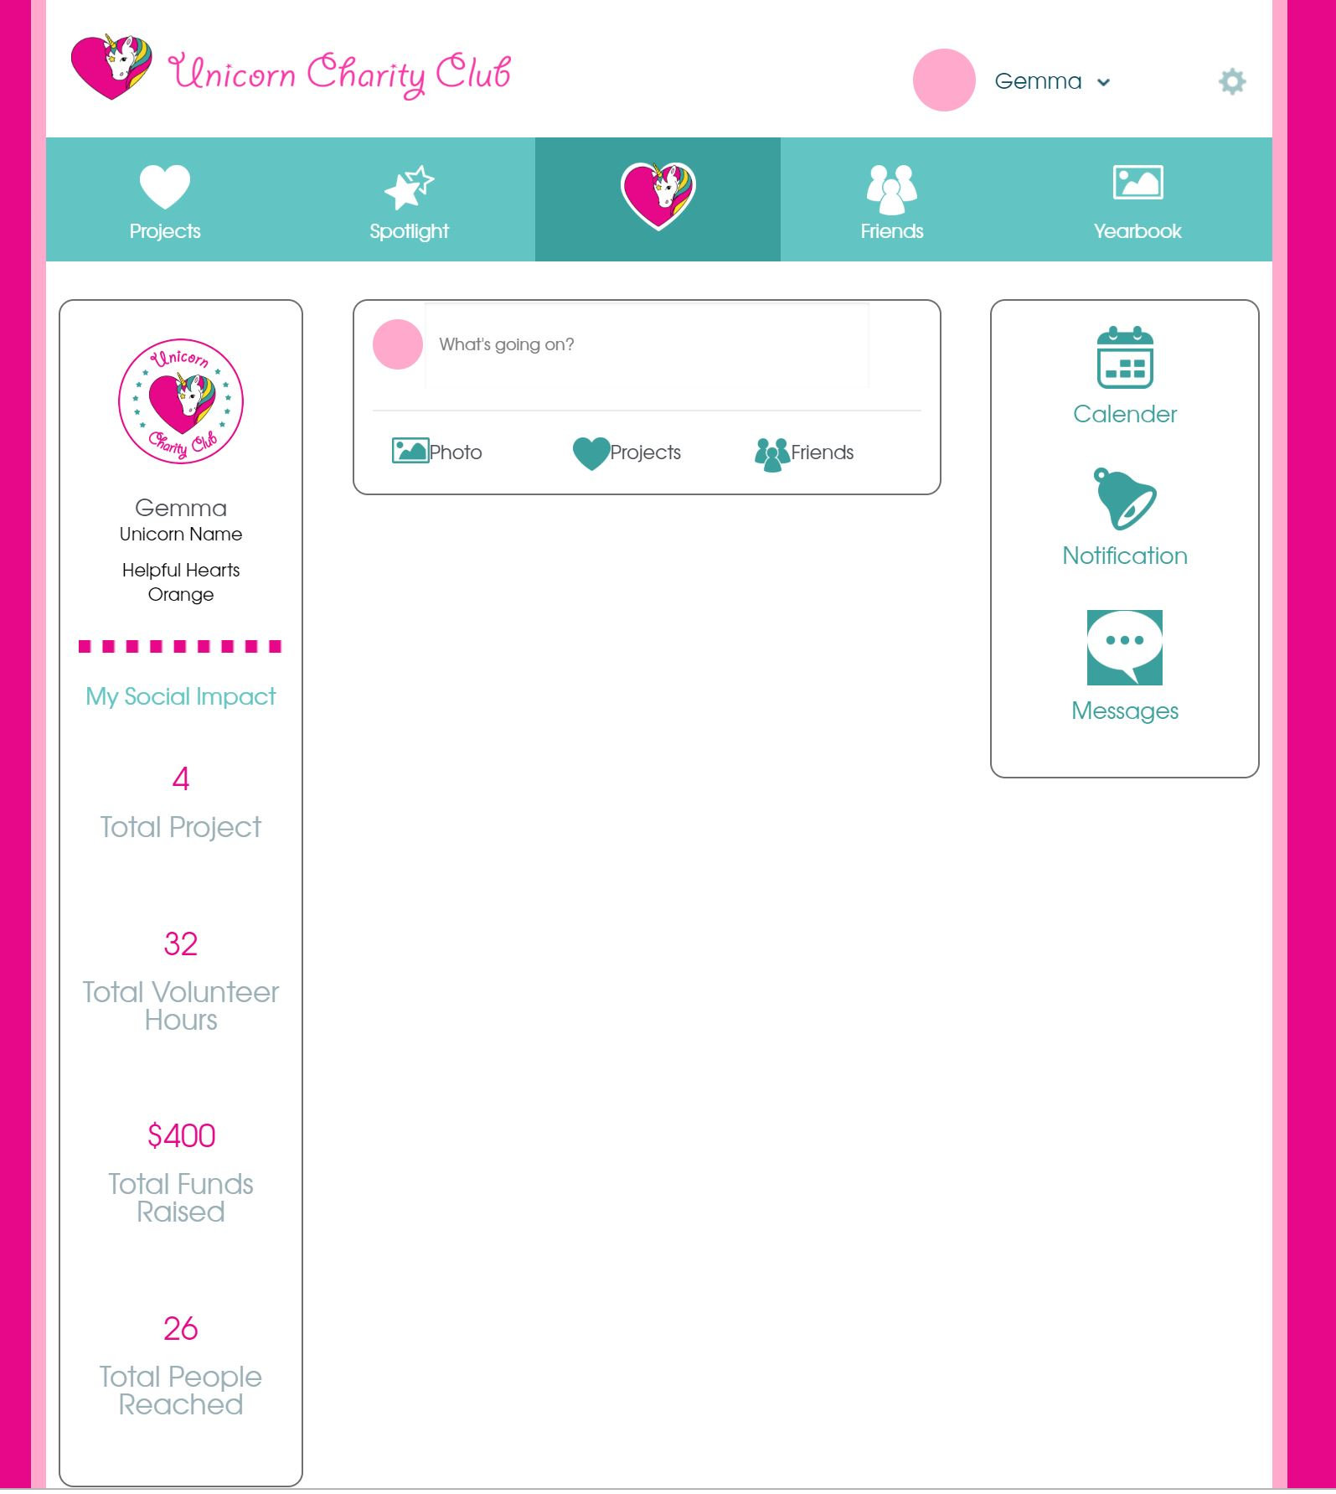

User is redirected to home page after logging in. The user data fetched from database should be unique to the user.

User can :

Navigate through different pages in the navigation bar, check messages, notifications, and calendar.

View their profile briefly on the sidebar

Post (and show all posts with data like text, photos, tags, likes, comments fetched from database).

Switch between children or add a new child in the dropdown in header.

View their account or log-out in the setting icon in header.

**Homepage Mobile**

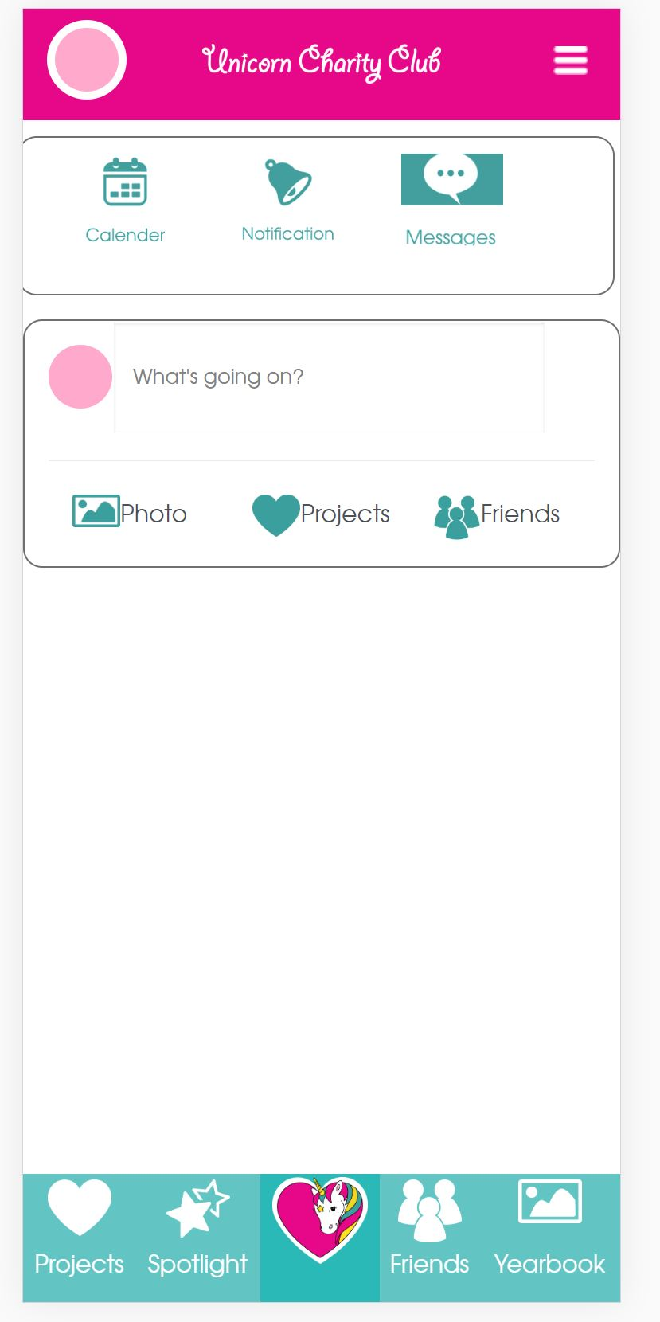

User can access the menu by clicking on the top right list button, which has access to account page, adding or viewing children, making payments, terms and conditions, security and privacy, and log out.

**Projects Page**

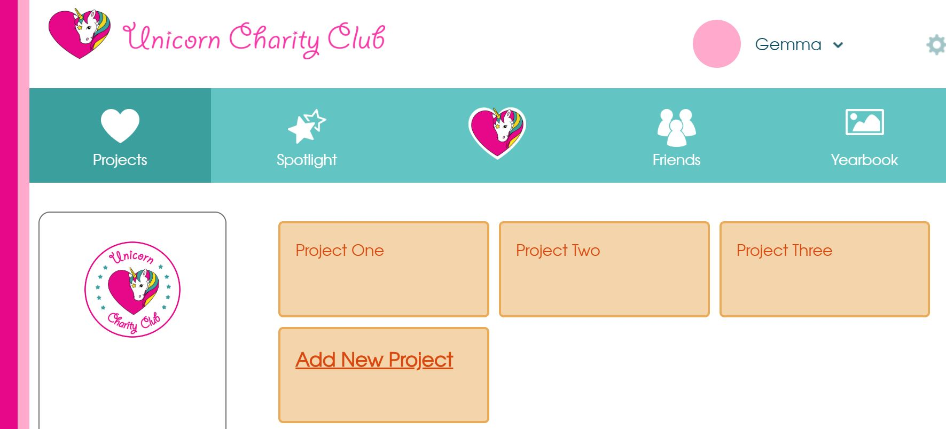

Users can view projects added by the admin. The option of adding projects should only be available to users with admin role, which can be done in the firestore backend.

**Add New Project**

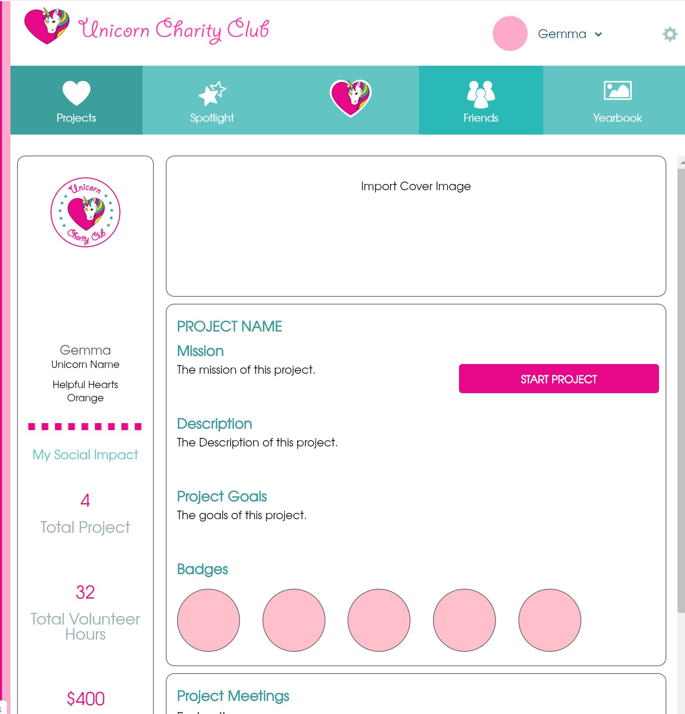

Admin can create, edit and add a new project. It should add data to the firestore database. Data should be fetched from it and be shown to users on projects page.

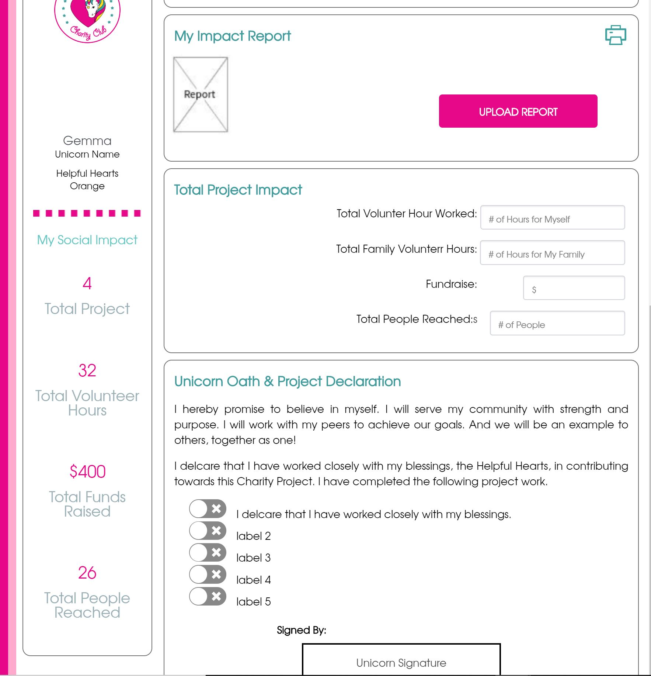

**Projects Mobile**

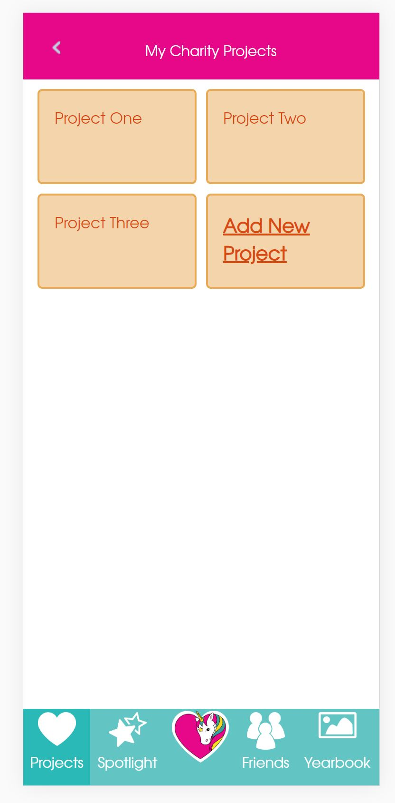

**Add Project Mobile**

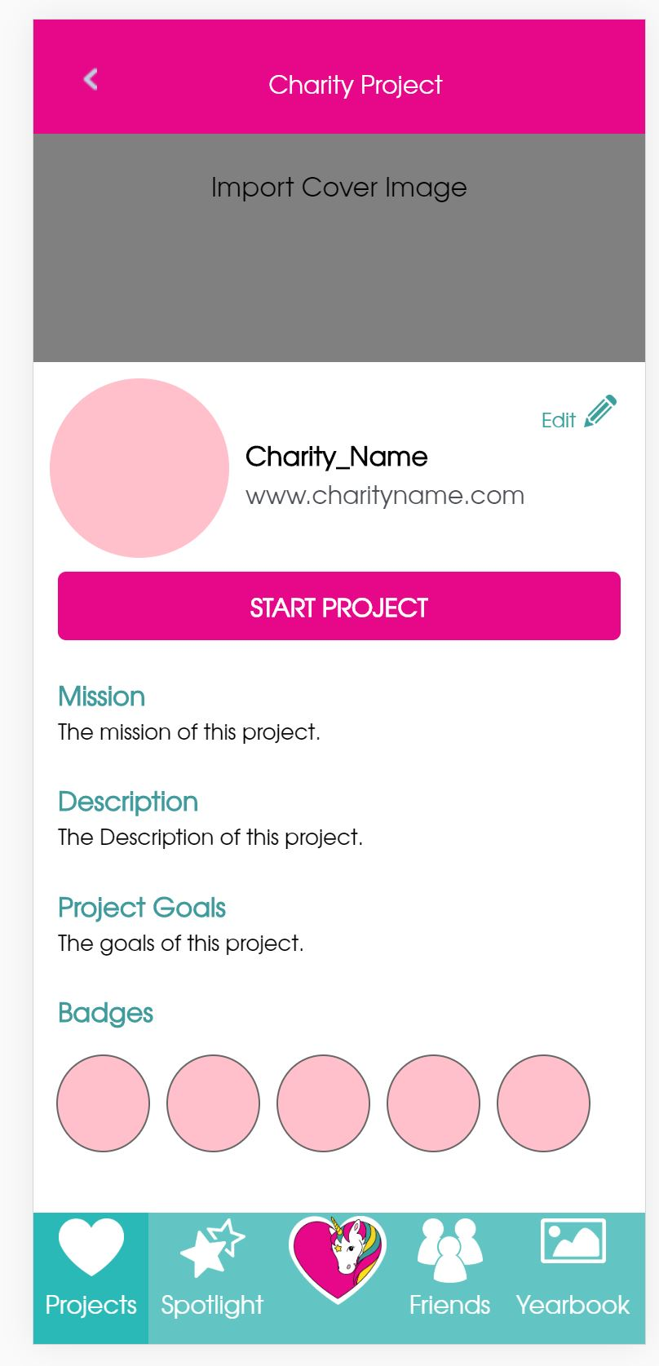

**Spotlight Page**

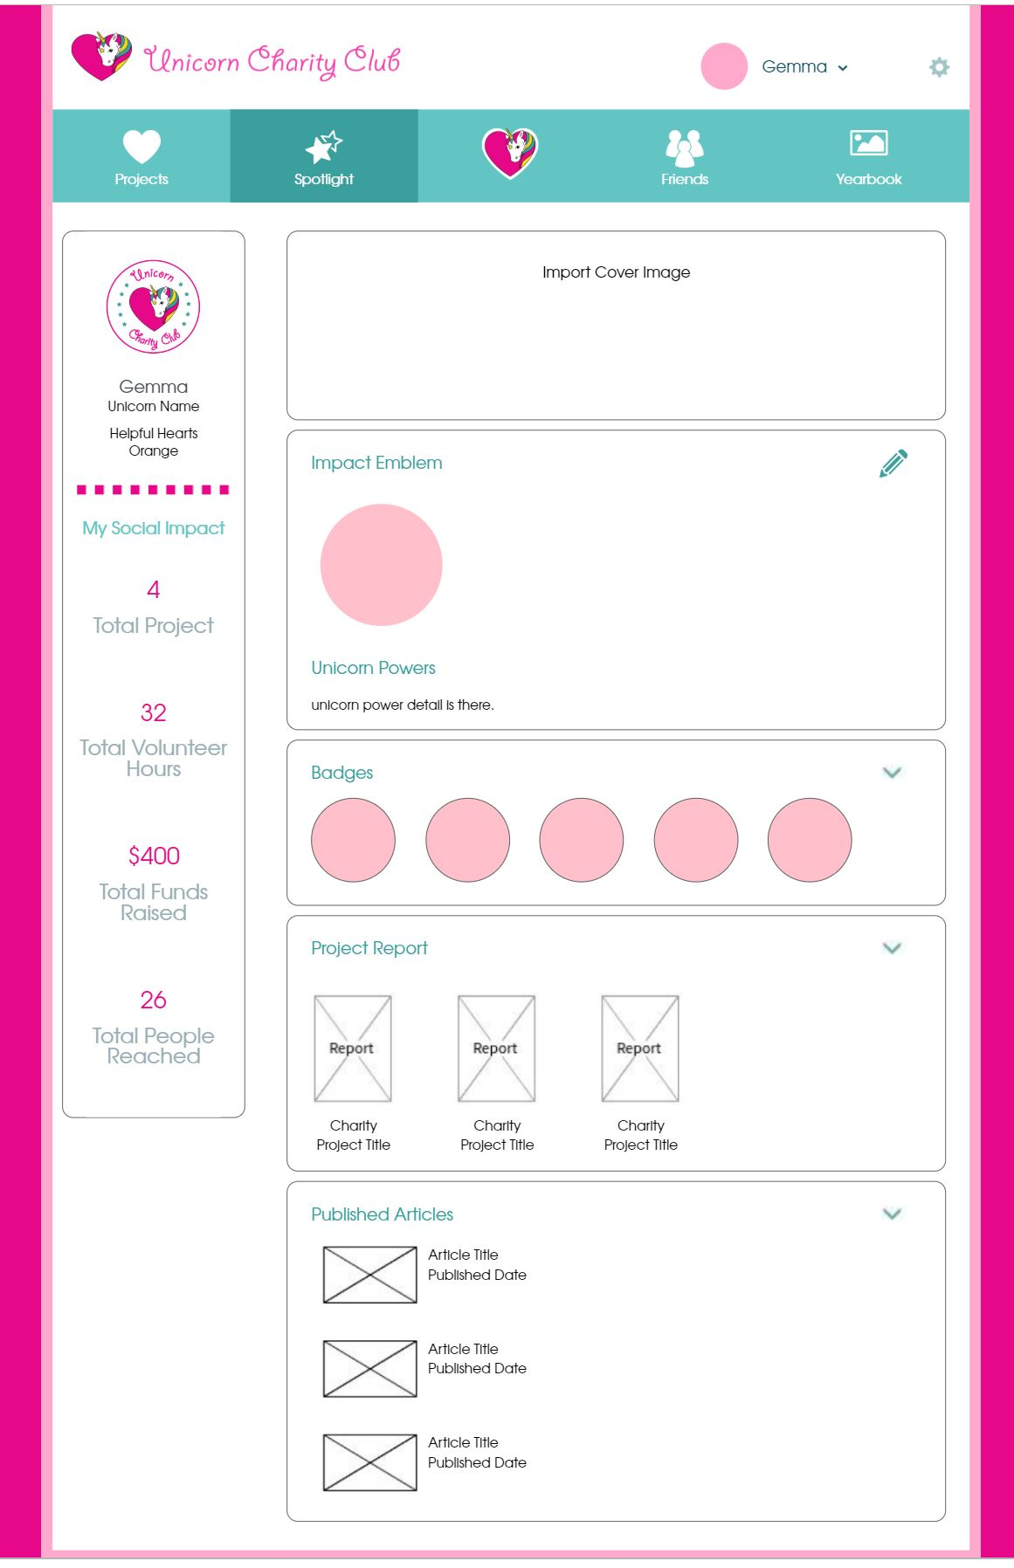

**Spotlight Mobile**

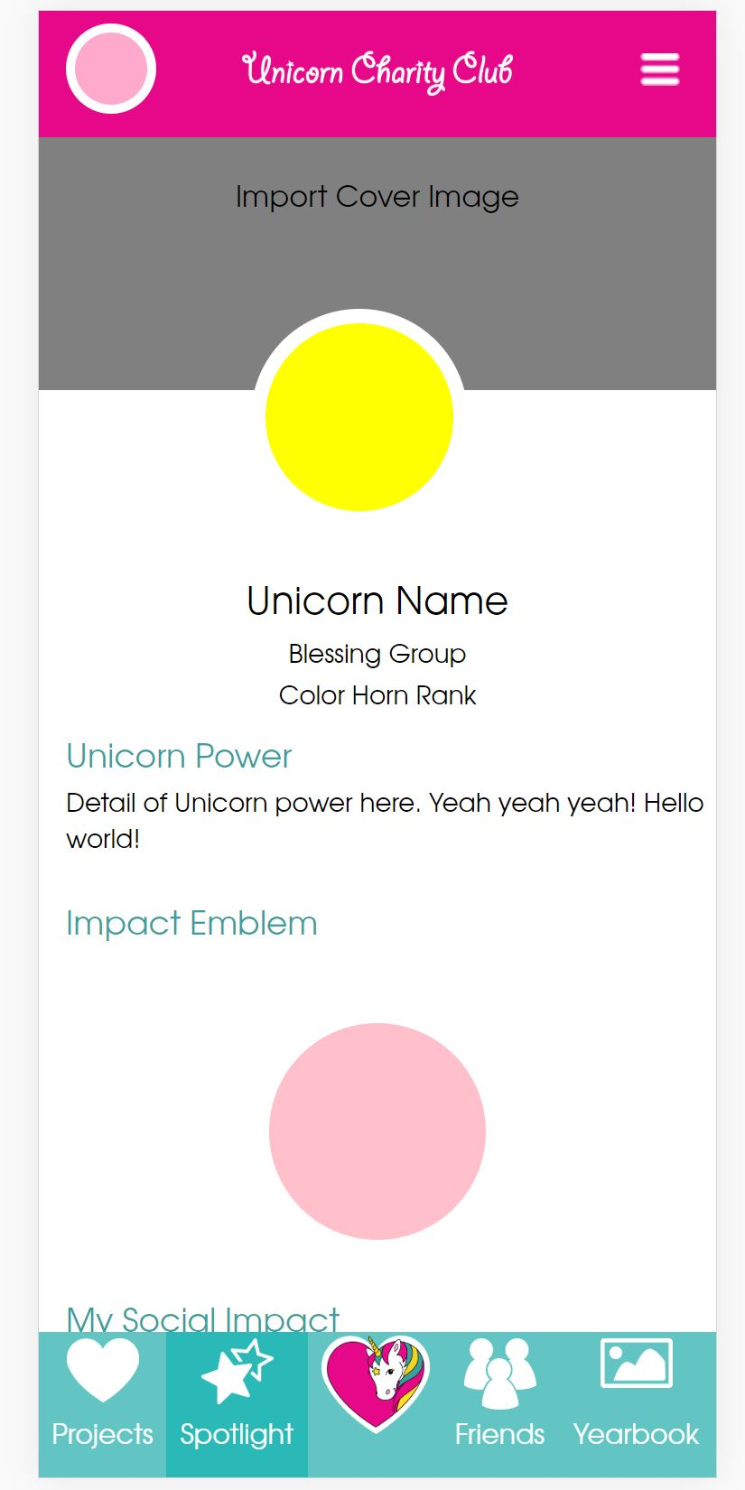

Users can:

Import Cover Image

Clicking on the edit button will take the user to my children page where they can edit their info.

View Projects reports, badges, published articles.

**Friends Page**

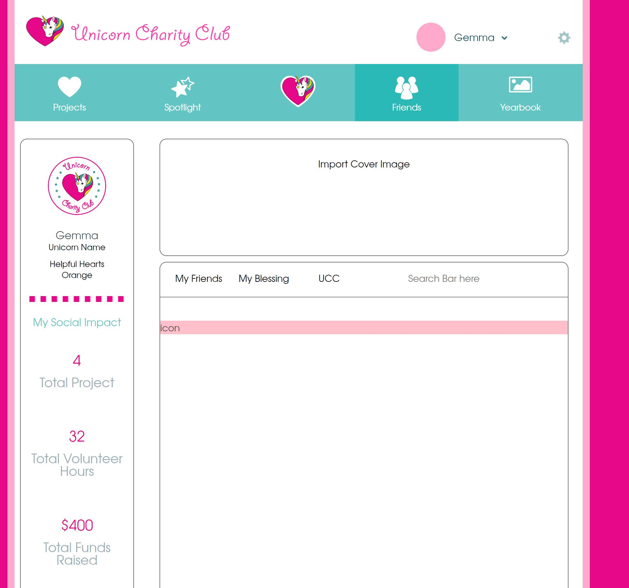

**Friends Mobile**

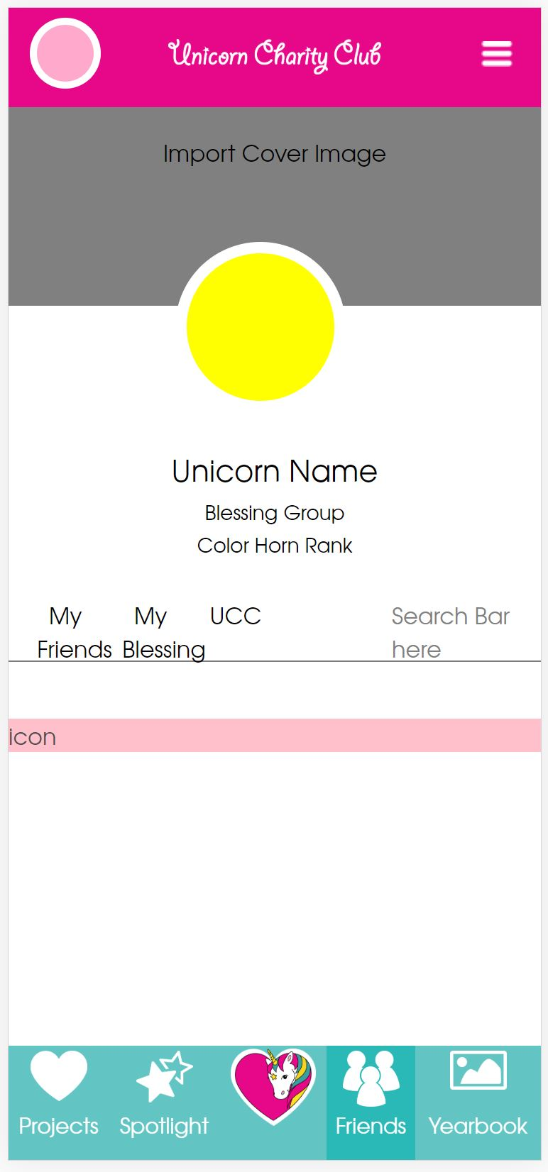

Users can view their friends, view members across their tribe, or view members in UCC. User should also be able to message other users clicking on the messages button (not shown here currently).

Data like friends list, their names, images, link to their profiles, etc. is fetched from database.

**Yearbook Page**

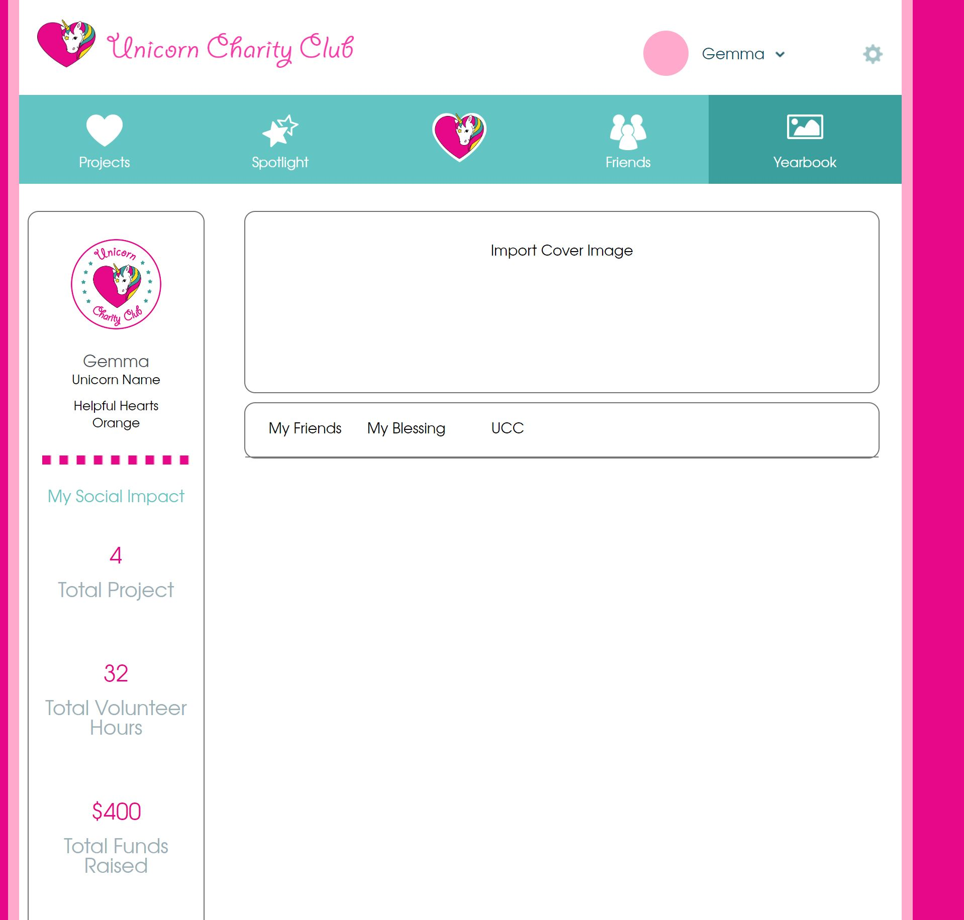

Users can view their own photos, photos across their tribe members, or all photos in UCC.

**Yearbook Mobile**

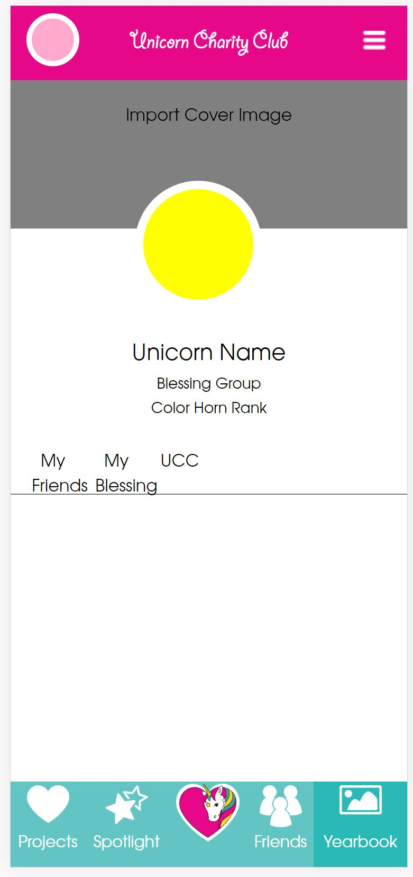

**Menu Mobile**

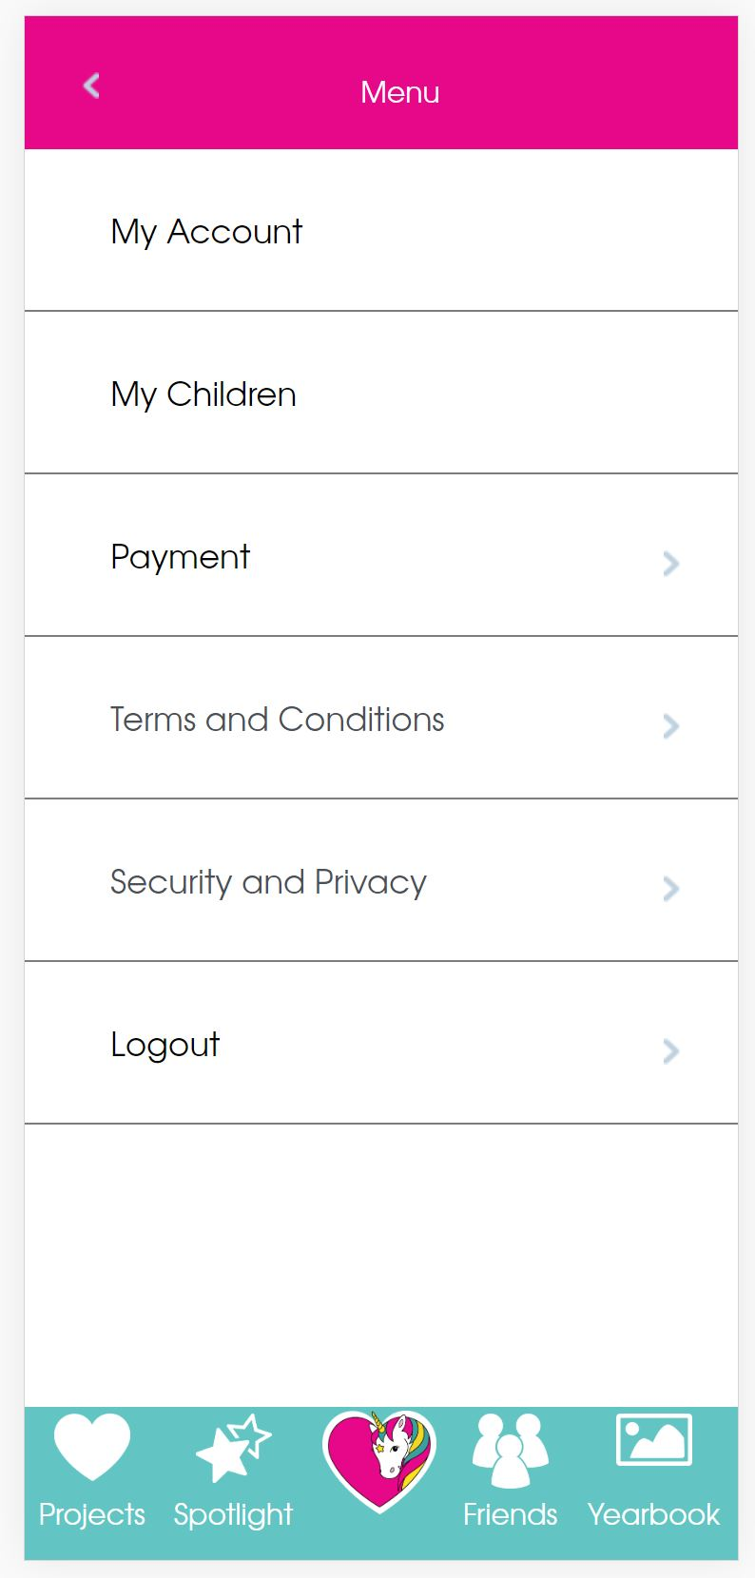

Lists my account, my children, payment, terms and conditions, security and privacy, and logout. User can navigate through these pages and click on the back arrow button to go back.

**My Account**

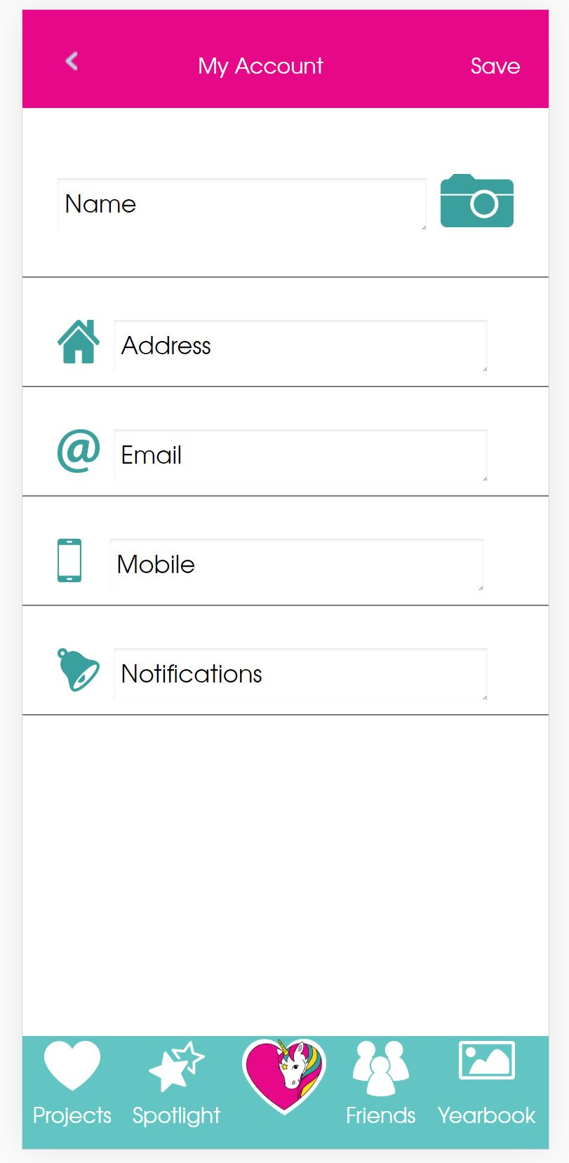

Edit name, address, email, mobile number, and notifications.

**My Children**

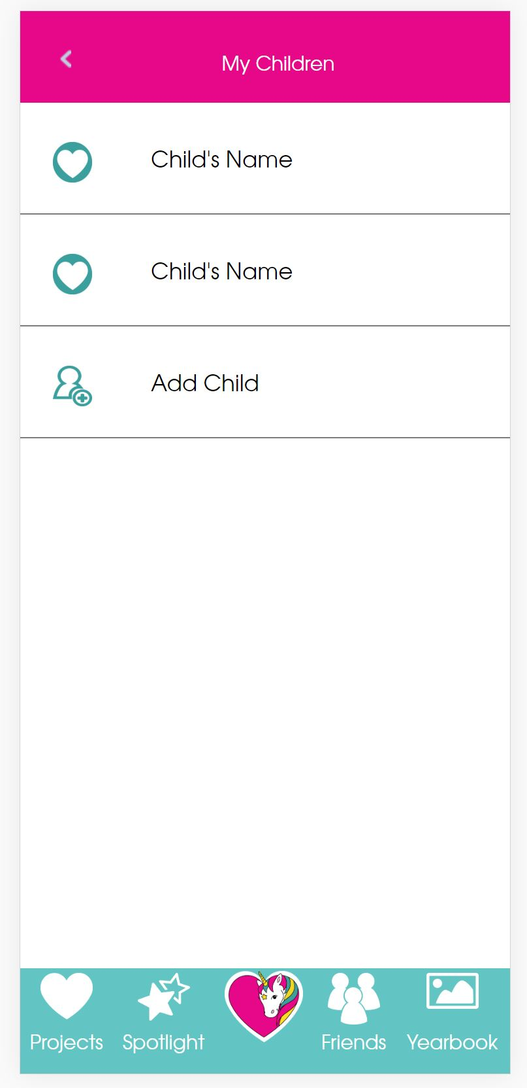

Click on child to edit/view their info.

Add a new child.

**Add new child**

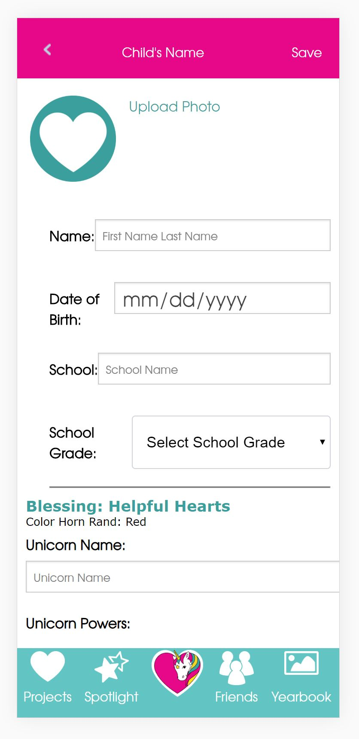

**Footer desktop**

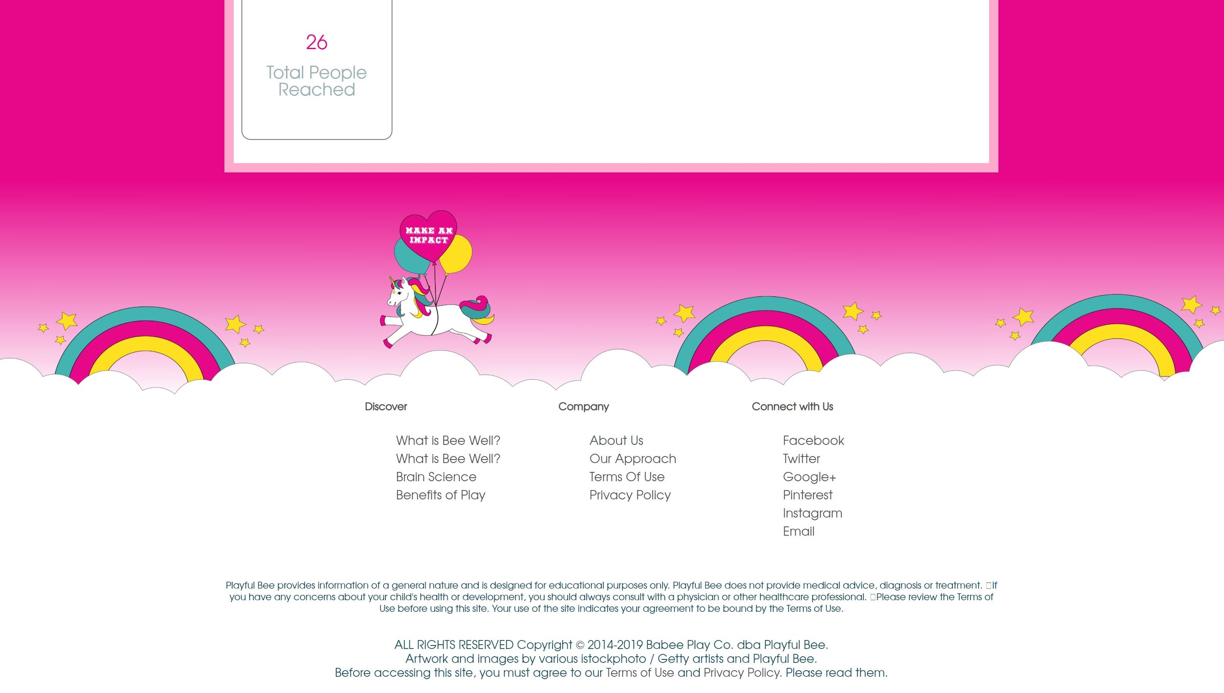

Navigate to pages like about us, privacy policy, terms and conditions, etc.

Links to social media sites.

**Payment Page**

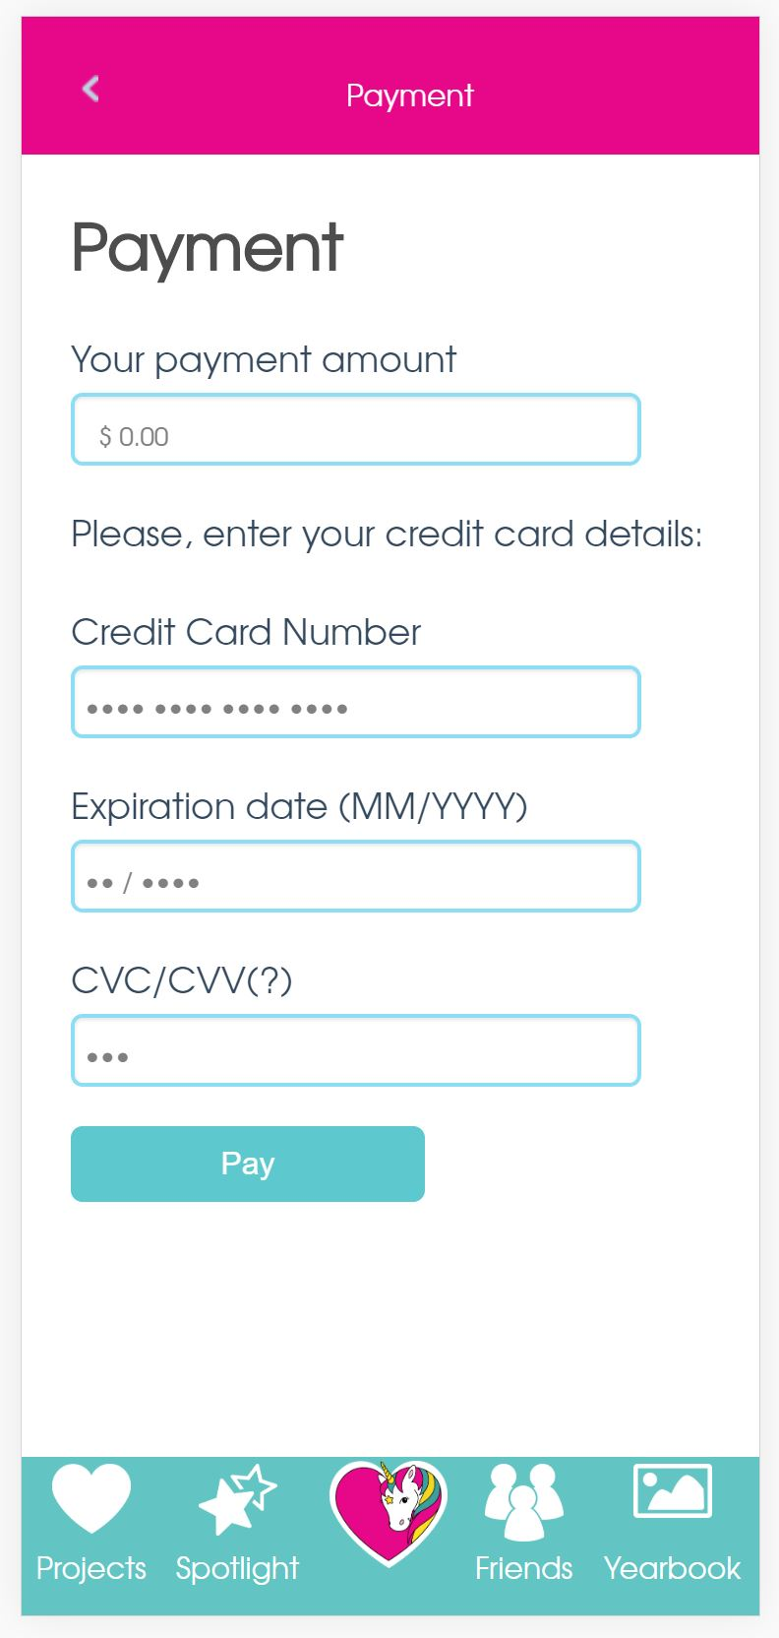

Users can make payments here using stripe checkout.